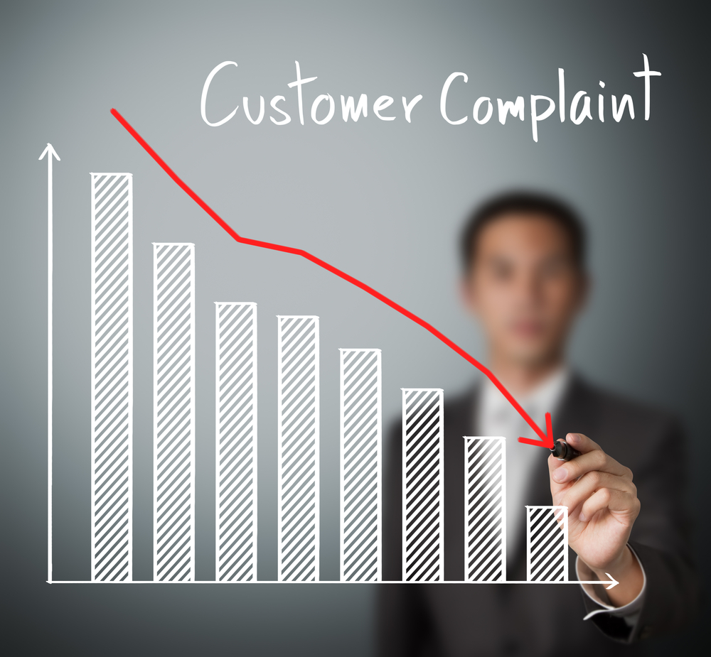

**Consumer Complaints related to financial products and services**

**CIS 5270: BUSINESS INTELLIGENCE**

**Spring 2017**

**By Narendra Mali**

**Submitted to: Dr. Shilpa Balan**

1. **Dataset URL**

<https://data.consumerfinance.gov/dataset/Consumer-Complaints/s6ew-h6mp>

The above URL contains entire data of Consumer complaints related to financial product and services from Year 2011 till Year 2017. It has total of 18 columns and 719,795 rows with each column and row giving meaningful details related to the topic. It contains details such as Date at which complaint is received. Location, State and zip code at which complaint is registered along with response date, timely response, product details along with Issue. Product and Issue are sub divided into sub-product and sub-issue which give proper explanation of the issue. Explanation of the consumer as well as from company representatives side is listed in systematic format. Important part is that for some of the complaints companies have provided their public response, those are also listed under company response category. State names are abbreviated and last column is represented as complaint ID. This dataset is updated every quarter under CFPB website.

1. **Data Cleaning:**
2. Data and Zip code do not match: Zip code 54020 belongs to WI state but was listed under CA state. Used “vlookup” formula in excel to match the zip code with correct list of state.

Before After 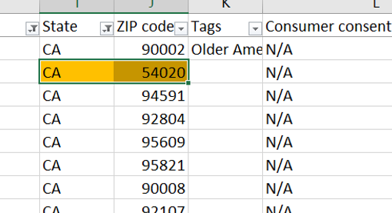 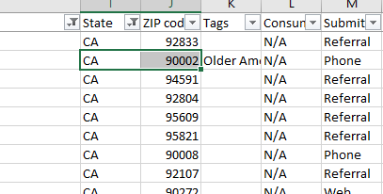

1. Missing values: Removed missing values

Before After

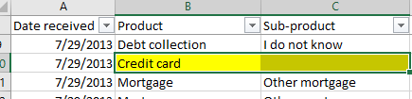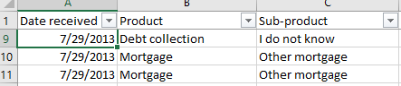

1. Excel formatting error: Zip code was 4 digit instead of 5 digit. It was missing a 0 in the end.

Before After

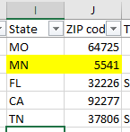 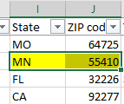

1. Date format was converted from general to Date: Date was not in MM/DD/YYY format.

Before After

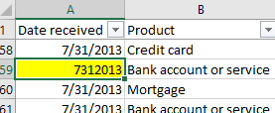 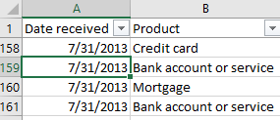

1. Improper Value: Y was present instead of Yes.

Before After

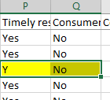 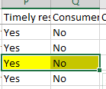

1. **Data Visualization**

**Question 1: There are various complaints registered for different products of financial services. Number of complaints over the years for different products in year by year format?**

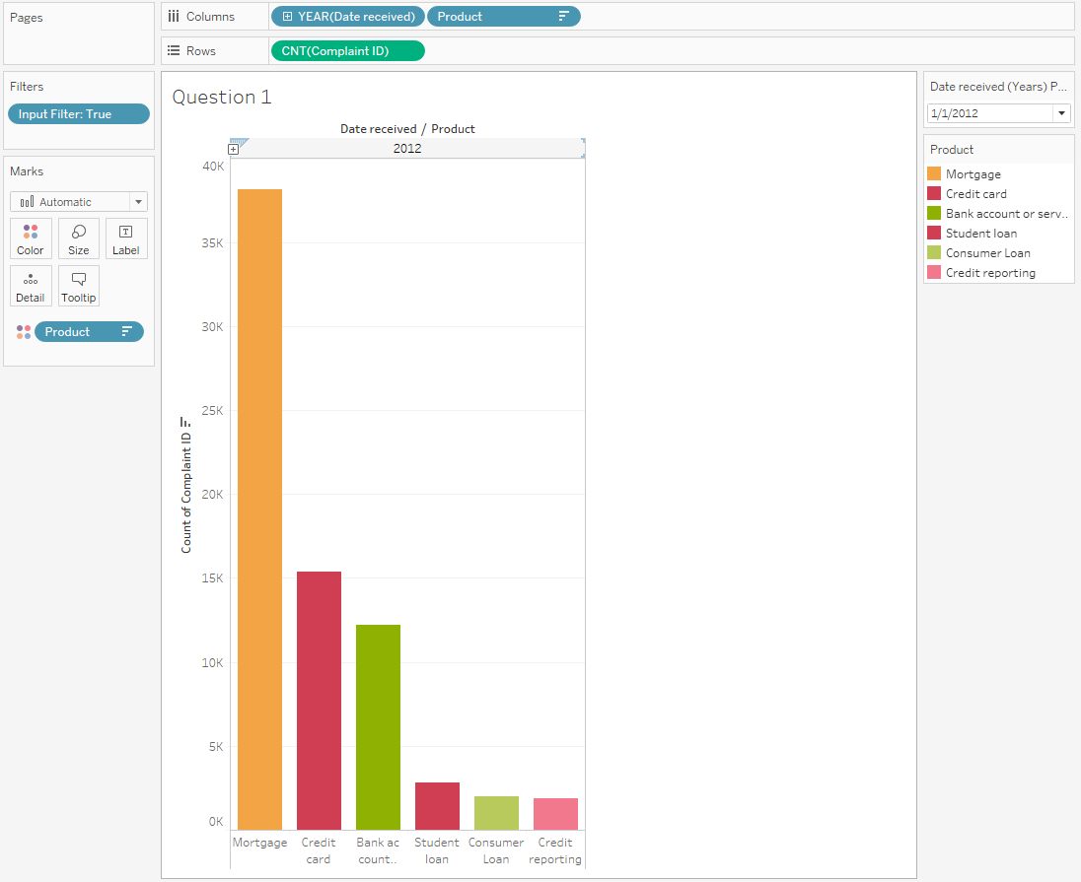

[Tools Used: Dates, Parameters]

This is the year by year Bar graph of all the complaints received for different products. Total number of complaints for year 2011 were 2540 and for year 2016 were 191,371. Complaints are keep on increasing for every year. Year from date is used to create parameter in the bar graph. By using parameter, date can be changed from parameter control to check number of complaints for each year. It is required to analyze causes and areas which are receiving large number of customer complaints. Graph shows that from year 2011 onwards maximum number of complaints were received for mortgage followed by Debt collection and Credit reporting. Till year 2016, Mortgage complaints leads for maximum complaints from consumer with total of 219,216 that counts for 36,536 complaints per year on average.

**Question 2: Which are the financial services who provides fastest reply?**

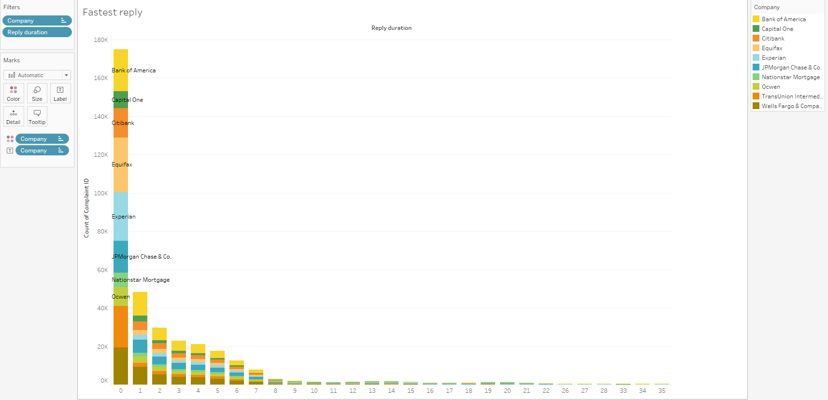

[Tools Used: Calculated field (Reply Duration)]

For any services consumer are the important part and resolving their issue is utmost important. Reply duration is calculated by using Complaint received date and Complaint closed date. Companies like Bank of America, Capital one, JP Morgan Chase etc. are those financial services which manages to close maximum of their customer complaints on the same day. Even though Capital one, Bank of America manages to close their consumer complaints on the same day, there are some complaints present which states that complaints remains unresolved even after one month.

**Question 3: Mortgage related complaints for all the States?**

[Tools Used: Geographical Maps]

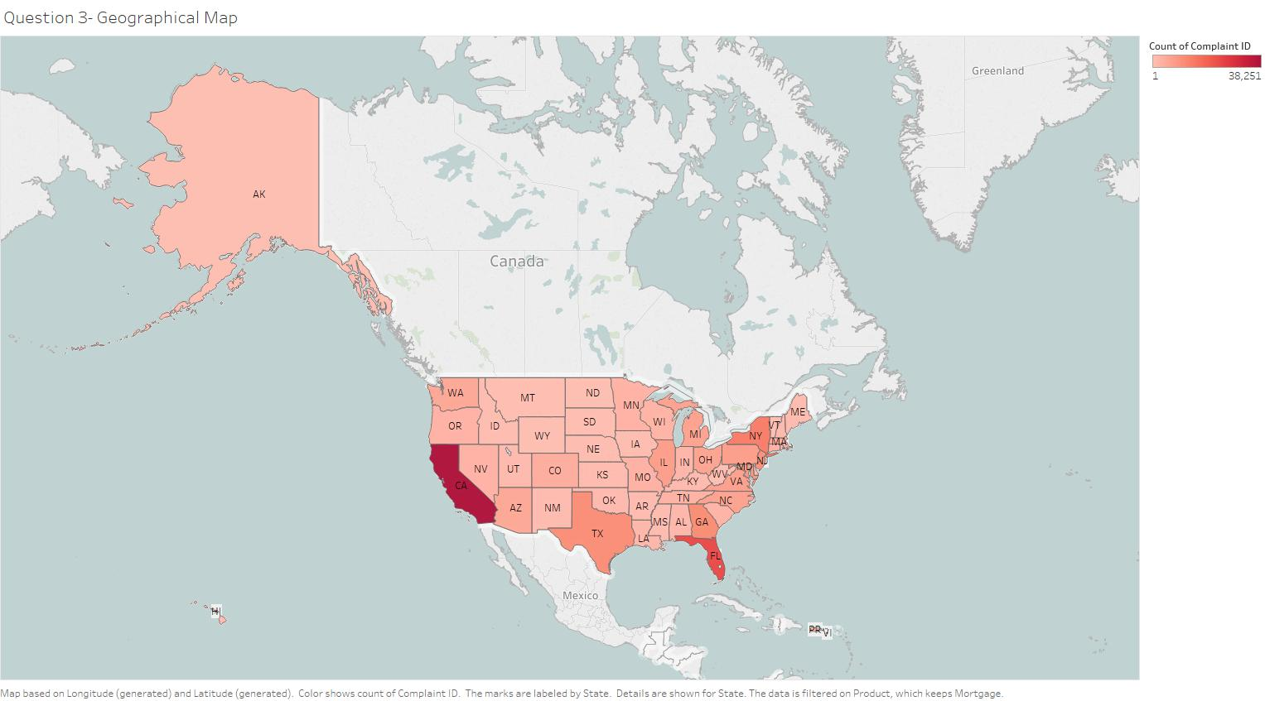

Mortgage related complaints are more in numbers compared to other complaints. By using Latitude and longitude geographical map has been plotted. This geographic maps shows us the distribution of consumer complaint related to mortgage across the Unites States. There are some states which have not received many complaints over the years for mortgage. Those states are Hawaii and Kentucky. California is leading the race with maximum number of mortgage related complaints, followed by Florida state.

**Question 4: Top financial services in each category of Company Response to consumer?**

[Tools Used: Box & Whisker Plot]

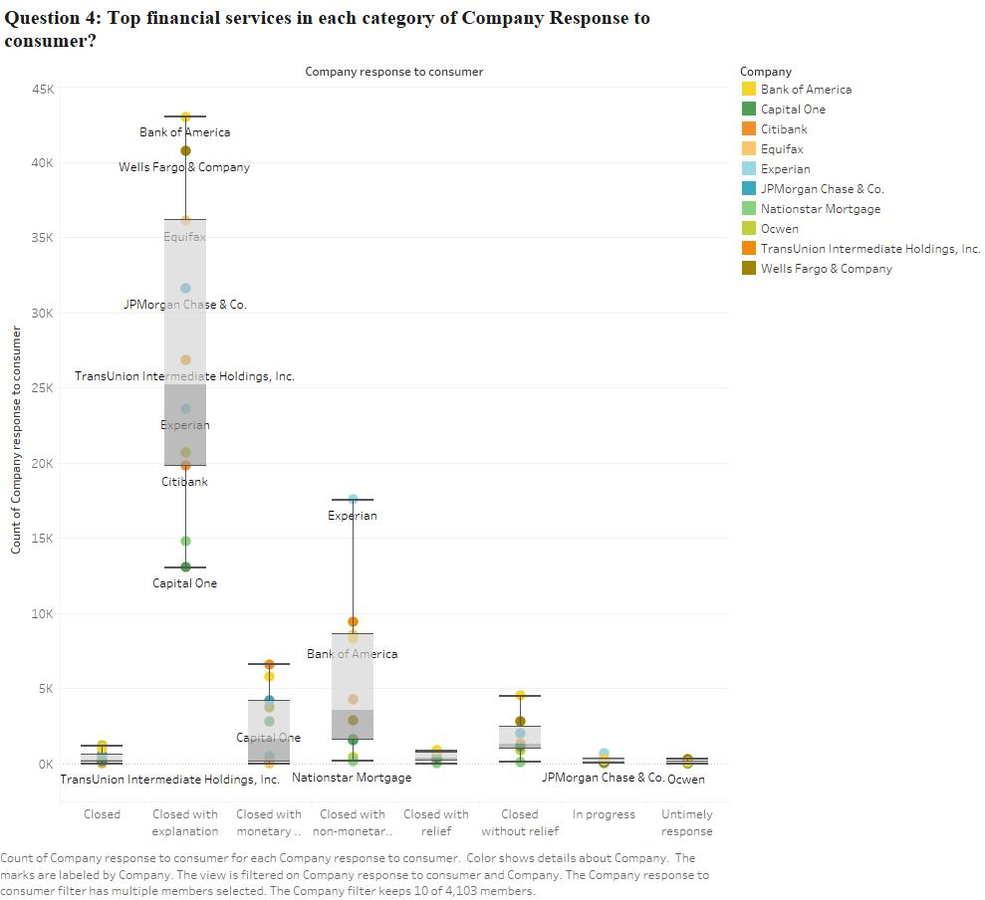

When any complaint is closed, it is closed with 8 different types of response. Complaints may be closed with explanation or without an explanation, closed with relief/without relief or it might be still in progress if we are considering latest responses. From the above Box & Whisker plot, complaints which ended with explanation are more than any other category. Bank of America manages to tops which is represented at the top of the whisker. Companies such as Bank of America, Wells Fargo and Equifax are in the top 25% of the companies to close any complaint with explanation. Capital one is at the bottom of the whisker and Citibank is on lower quartile. Same goes with complaints that are closed with non-monetary relief. Equifax is amongst the top and Nationstar Mortgage is on the lower part of the whisker.

**Question 5: How many complaints are received by bankers and lenders in each state of USA for Year 2016?**

[Tools Used: Reference Line]

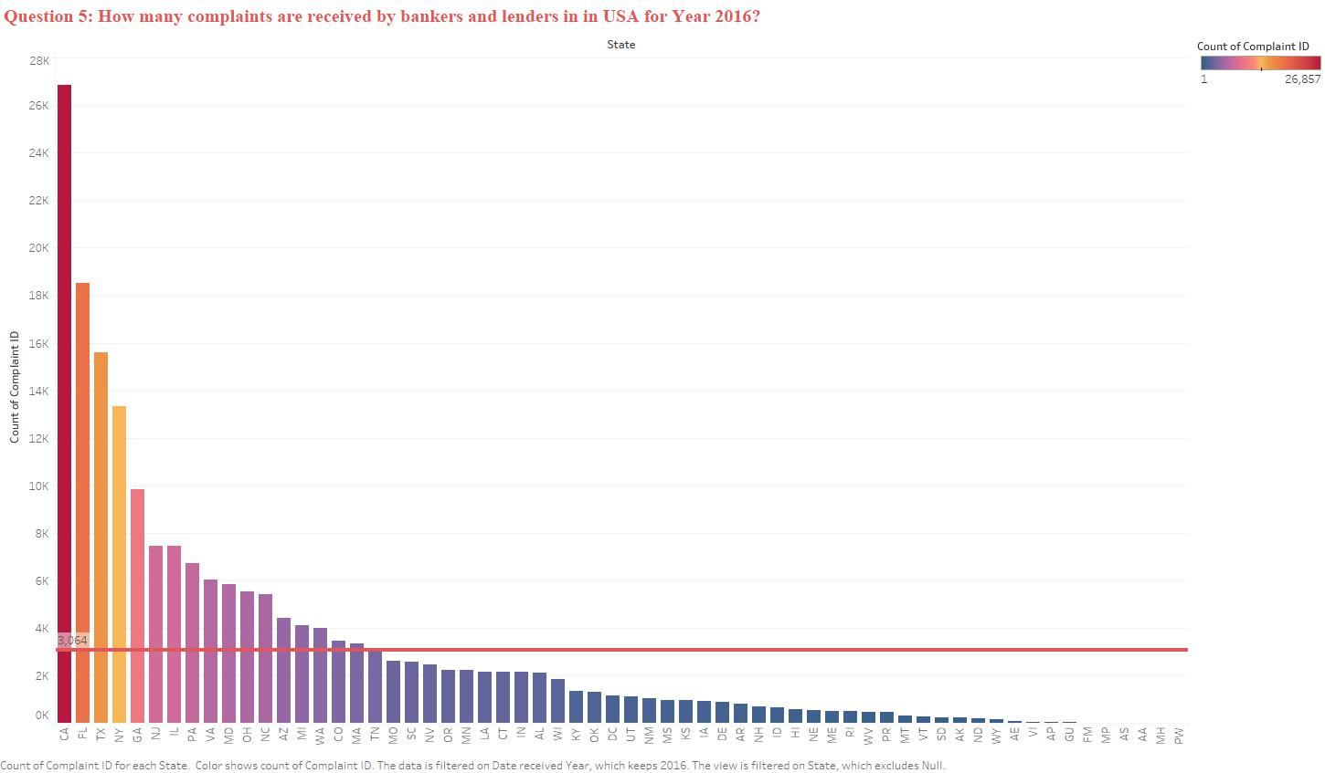

There are 191,371 complaints received across all categories and across the Unites States. Above Bar chart represents state wise distribution of those complaints. California has received highest number of complaints with 26,857 complaints whereas Wyoming state has received only 170 complaints in year 2016. Average for number of complaints across USA was 3,064 complaints which is represented by a reference line in above bar chart. Tennessee state has received just over the average number of consumer complaints (3101).

**Question 6: Number of complaints for Top 10 products and their sub product from year 2011 till 2016?**

[Tools Used: Groups]

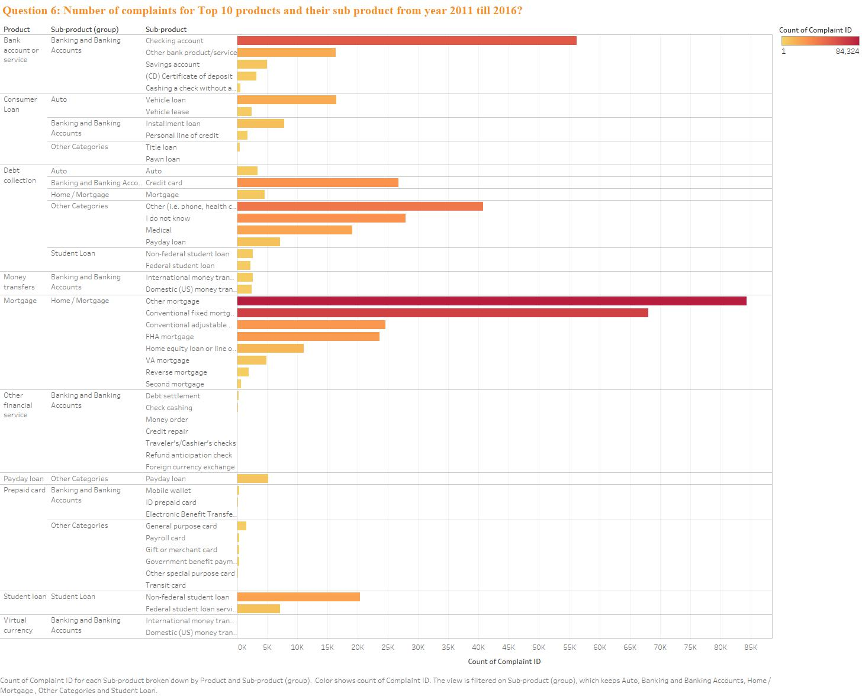

There are more than 84,000 complaints for Top 10 products. There are different sub product groups for each product. Groups are categorized based on their functional roll. Vehicles has their separate group such as, Auto group includes Auto, Vehicle loan and vehicle lease. Student loan group includes federal & non-federal student loan along with federal loan servicing. In Auto group, there are only 22,325 complaints received as compared to mortgage group which has received highest number of complaints and which contributes to amongst 40% of the groups. Second major contribution goes to Banking and banking services.

**Question 7: To estimate number of complaints in Year 2018?**

[Tools Used: Forecast trend Lines]

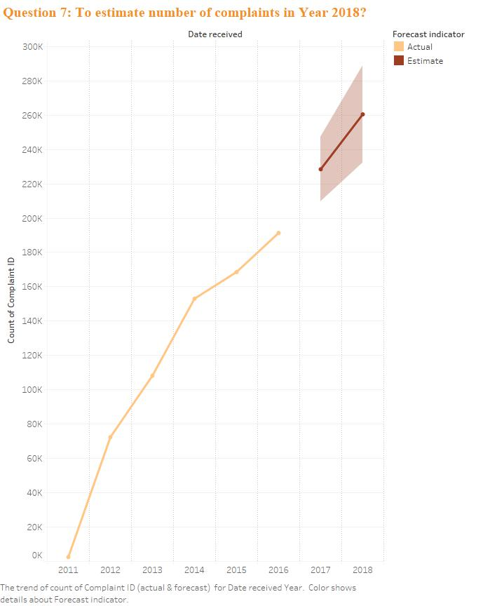

In year 2011, there were 2,540 consumer complaints received. Every year after 2011, there has been a significant number of increase in complaints. In 2012, 72,402 complaints received where as in 2013 the number were increased by 50% to 108,226. This number is keep on increasing till first quarter of 2017. By these forecast trend lines, we can estimate that by year end (2017) we will get 228,452 complaints and by year 2018 we will receive 260,458 complaints. This number is significantly higher as compared to previous years. In year 2018, complaints received will be 70% more than they received in 2014 and as compared to 2017, those will be 14% more.

1. **Dashboard**

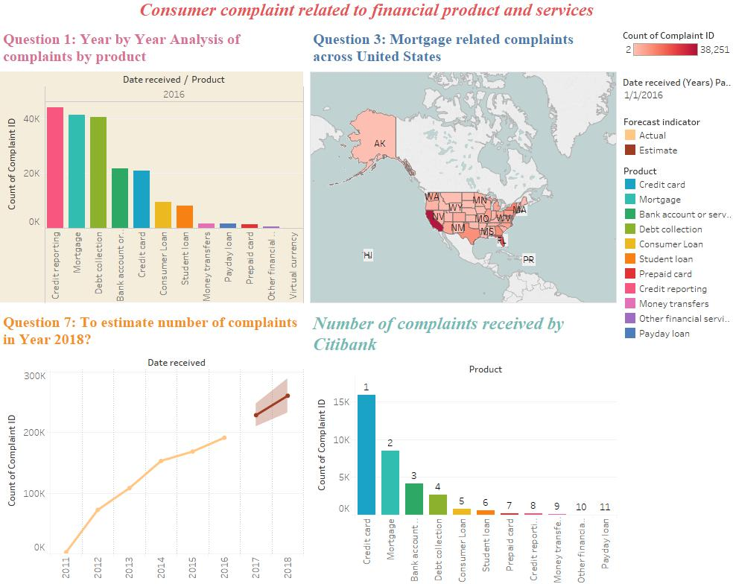

1. **Storytelling**

Americans have created billions of dollars’ worth of debt over the past 45 years, and credit card debt has been an important part of that. Credit card debt dove -- along with consumer spending -- during the 2008 financial crisis and slow growth has kept total revolving debt at pre-crisis levels, though it is creeping up. According to figures from the Federal Reserve, total U.S. outstanding consumer debt was $3.62 trillion as of May 2016. That figure includes car loans, student loans and revolving debt, but not mortgages. Total U.S. outstanding revolving debt, which is chiefly made up of credit card balances, was $953.3 billion as of May 2016. (Gonzalez)

“Credit cards are an important tool in the day-to-day financial lives of a large number of consumers,” said CFPB Director Richard Corday. “It is important that credit card companies are being straightforward and clear about the costs and fees associated with their products so consumers have the information they need to make informed financial decisions.” (Unknown).

After analysis, complaints found for credit cards are 84,147. These complaints contribute to the 12% of the total complaints across all products and loans. From following graph, it is clear that Citibank has received maximum number of complaints i.e. 15,921 for credit cards from year 2011 till Q1 of 2017, followed by Capital One and JPMorgan Chase.

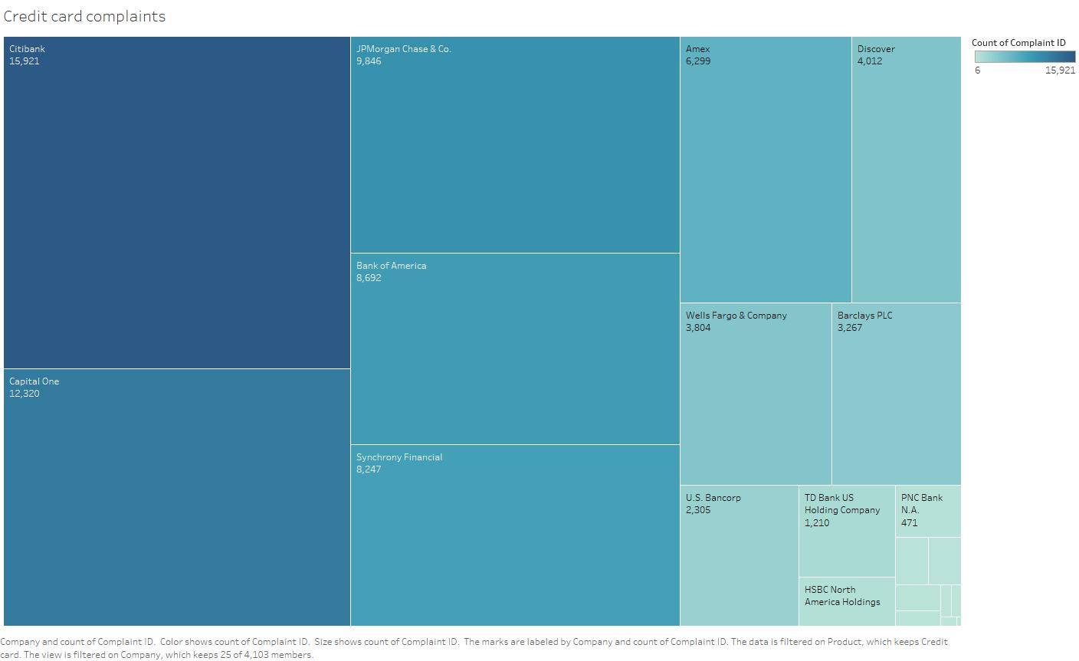

Credit cards are found in most Americans' wallets. Multiple studies say about 7 in 10 Americans have at least one credit card. Federal Reserve data released in 2015, for example, found 70 percent of consumers had at least one credit card. Using the Census Bureau estimate of 248 million adults in the U.S., that means there are about 174 million Americans adults with at least one credit card. (Gonzalez-Garcia)

|  |  |  |  |
| --- | --- | --- | --- |
| **HOW MANY CARDS OF DIFFERENT TYPES DO AMERICANS HAVE?** | | | |
|  | **2011** | **2012** | **2013** |
| **Credit cards** | 3.6 | 3.9 | 4.1 |
| Rewards | 2.0 | 2.2 | 2.4 |
| Nonrewards | 1.7 | 1.7 | 1.7 |
| **General purpose credit cards** | 2.3 | 2.4 | 2.7 |

As seen from the above report that there are 2.4 per person for rewards credit cards. This number is particularly important since there are more than 2500 complaints specifically for rewards credit card. From the packed bubble chart, it is safe to say that Citibank, JPMorgan Chase and Bank of America should improve their rewards systems since most of the complaints received are fairly new i.e. those are from year 2015-16. Since, rewards card holders are more in number than any other card holder, it is highly required that companies should focus on this information and improve their services. Consumers complained about difficulty receiving benefits promised to them through special rewards programs. These consumers said that the terms and conditions of how these rewards programs worked were not adequately explained to them when they initially signed up for their credit card. Some of the types of programs that people complained about included bonus points or miles programs, cash back programs, and travel benefits programs. (CFPB)

Over the years’ credit card complaints remains one of the big issue for financial services. From year 2011 till Q1 2017, credit card remains in top 5 product which are receiving most complaint. Bar chart shows that it started in year 2011 with modest of around 1250 complaints till 2016 where complaints were around 20,500. This number is significantly increasing year by year.

Consumers frequently complained about trouble understanding the decisions made by credit card companies regarding the consumer’s initial application for a card, as well as changes made to the interest rate charged. Many consumers believed these decisions were being made in relation to existing items on their credit report that they feel do not reflect their creditworthiness. (CFPB) Stacked bar chart shows the actual difficulty that general public is facing regarding APR and Billing disputes complaints. Billing disputes and APR related complaints contribute to majority of the complaints in credit card product. As from the earlier discussion, Citibank leading in credit card complaints in all issues and that is no exception for APR and billing disputes. Capital One and JPMorgan Chase are respectively at number two and number three spot.

Another Category which is contributing nearly 40% in consumer complaints is Mortgage related complaints. Banks are inundated with these complaints every day and they try to reply to each and every complaint on the day zero. From the geographical map, we can clearly distinguish which states are facing more mortgage related issues than others. While California is leading the race with maximum number of complaints (38,251). Consumer complaints from California were more likely to be about mortgages than consumer complaints nationally.

The majority of complaints about mortgages—51 percent—submitted to this dataset had to do with problems consumers faced when they had difficulty making payments. Consumers complained of prolonged loss mitigation review processes in which the same documentation was repeatedly requested by their servicer. Consumers also complained that they received conflicting and confusing foreclosure notifications during the loss mitigation review process. (CFPB-2)

Complaints submitted relating to credit reporting rose 35 percent between February and March of 2016. During the month of March, there were 3,321 credit reporting complaints submitted. Bank of America, Wells Fargo, and Experian were the three most-complained-about companies from consumers in California.

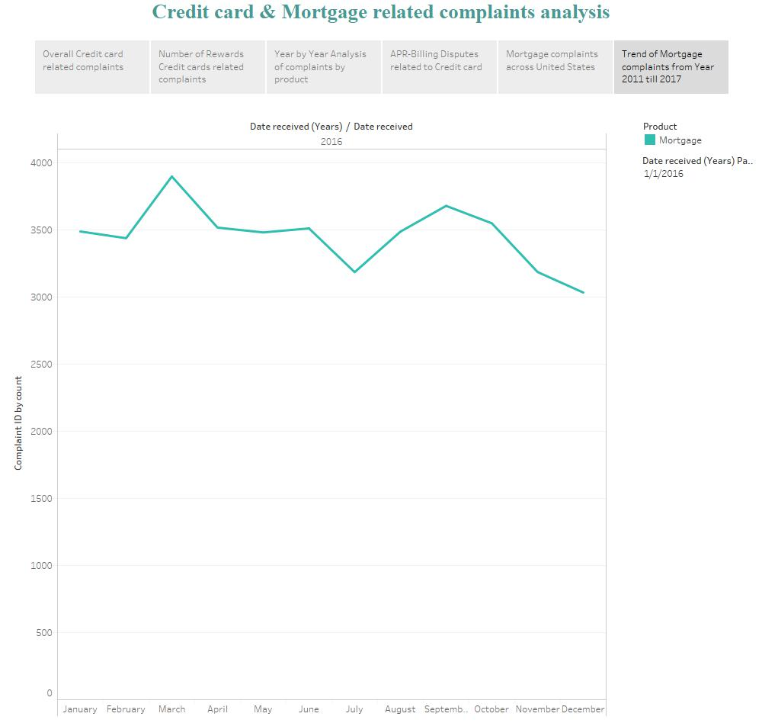

Finally, looking at these statistics and seeing such big players in this infamous list it raises serious concerns as to whether these big names really take care of consumers or not. Complaints number are ever so increasing with passing day. These complaints are only going to reduce only if efforts are taken from both the sides. Companies must have contingency plans ready even if one of the consumer faces the issue. Also, customer must read the terms and conditions carefully before signing up for any services. Calculations about finances and future plans and credit card debt, all must be calculated on personal level by the consumer beforehand so that less consequences will be faced. And even after all this, still number of complaints are going up then companies at least have a less response time.

# References

CFPB. *Consumer Financial Protection Bureau Monthly Complaint Snapshot Spotlights Credit Card Complaints*. 26 July 2016. Online article. 30 March 2017. <https://www.consumerfinance.gov/about-us/newsroom/consumer-financial-protection-bureau-monthly-complaint-snapshot-spotlights-credit-card-complaints/>.

CFPB-2. *CFPB Monthly Complaint Snapshot Examines Mortgage Complaints*. 26 April 2016. Online. 29 March 2017. <https://www.consumerfinance.gov/about-us/newsroom/consumer-financial-protection-bureau-monthly-complaint-snapshot-examines-mortgage-complaints/>.

Gonzalez, Jamie. *Credit card debt statistics*. Ed. Tamara E. Holmes. 31 January 2017. Web article. 25 March 2017. <http://www.creditcards.com/credit-card-news/credit-card-debt-statistics-1276.php>.

Gonzalez-Garcia, Jamie. *Credit card ownership statistics*. 25 October 2016. Article. 30 March 2017. <http://www.creditcards.com/credit-card-news/ownership-statistics.php>.

Unknown. *Consumer Financial Protection Bureau Monthly Complaint Snapshot Spotlights Credit Card Complaints*. 26 July 2016. Article. 29 03 2017. <https://www.consumerfinance.gov/about-us/newsroom/consumer-financial-protection-bureau-monthly-complaint-snapshot-spotlights-credit-card-complaints/>.